CONCEPT NOTE APPLICATION FORM:
PROSPER General/Climate Window 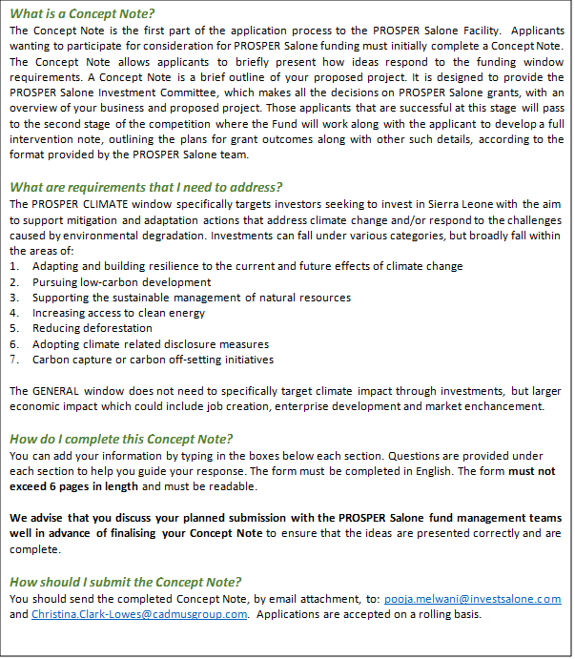

- Name of investment firm /initiative and type:
Name:

Type: [Insert for example, domestic or international investor, venture capital fund, DFI, debt fund, etc.]

Website URL:

- Lead contact person for this submission:
Name :

Address:

Telephone:

Email:

- Partner Organisations (if any)
Name :

Address:

Telephone:

Email:

- Project Summary
Please summarise the key objective of the project for which funding is desired, and the rationale for seeking funding for the same from Prosper Salone.

- Approach and Key Activities of the Project:
Being as precise as possible indicate which of the eligible areas of one or more of the following your project will address for which you are seeking the grant:

- Develop a viable investment pipeline
- Conduct scoping trips
- Conduct a feasibility study
- Provide technical assistance
- Disburse investment capital
- Conduct due diligence for investments
- Support follow-on investment
- Other (please explain)

Please address the following questions:
- If applying under the Climate Window (otherwise please answer N/A), is there a specific sector focussed on climate that your activity plans to target? For example, clean energy, climate smart agriculture, waste management, etc.
- Highlight the scale of investment ($) that the project plans to undertake, along with the development rationale and projected social impact (in terms of jobs creation, income increase, energy saved etc.)?
- Explain where you are in the stage of the project (early launch stage, pipeline development stage, investment stage, etc.)
- Explain why you want to implement this project and your prior investment experience in the region (if any)?
- How will the project be commercially sustainable after PROSPER Salone funding? What is the additionality of seeking funds from Prosper?

- Expected Impact and Outcomes:
How is this project going to deliver significant benefits to firms and the overall investment climate in Sierra Leone? Does your project address any of the following:

- Increase in productivity of competitiveness to x number of companies
- Increase in exports or purchase orders of x number of companies leading to £x of exports by <month, year>
- Export-oriented commercially viable business innovations successfully implemented to expand exports or compete with imports
- X new permanent or part-time jobs created by this project by <month, year>
- Development of institutional investor network in Sierra Leone
- Increase in investment committed in Sierra Leonean firms
- Facilitation initiatives that strengthen the ecosystem of investors and buyers
- Any other impact outcomes planned
Explain briefly how the project aims to achieve the above outcomes?
- Estimated Risks
Please layout the potential or existing risks for the project activity being proposed:
Risk description | Level of risk  High/medium/low | Mitigation measures
1.
2.
3.
4.
5.
The above table shows 5 nos., the applicants can add more nos. (but no more than 10) if needed.
- Project Workplan and Timelines
Key activities / milestones for the project | Indicative completion date
1.
2.
3.
4.
5.
Applicants can choose to add more activities (but no more than 15) to the above table

- Estimated Project Budget:
Please note that the minimum contribution from bidders is 20% of the project’s costs. This contribution can be through in-kind and cash contribution. However, applicant contributions made through a high proportion of in-kind contributions (existing resources, staff etc.) will be considered dependent on the logic of the individual project proposed.

The budget for the project should be proportionate to the activities of the project proposed. The applicant company will need to share evidence for certain assumptions submitted if needed.

Project Items Requiring Funding, by Broad Category | Source | Investment Amount for the Project (in GBP)
1. Category – e.g., Pipeline development | Applicant
 | PROSPER Salone Contribution
2. Category – e.g., Scoping trips | Applicant
 | PROSPER Salone Contribution
3. Category – e.g., Technical assistance | Applicant
 | PROSPER Salone Contribution
Total Contribution | Applicant
 | PROSPER Salone Contribution

The above tables show 3 categories, but applicants are welcome to break down the category items into a greater number (but no more than 10), if you wish.

By signing this form our organization and consortium partners accept the following terms and conditions:

- We accept that we are bound by the process and rules of the PROSPER Salone Facility that have been highlighted on the Prosper Salone webpage and shall accept the outcome of the process without any deviation or reservation.
- We shall bear any and all costs related to the preparation and/or submission of the proposal, regardless of whether its proposal is selected or not. We accept that PROSPER Salone nor its implementing donor, UK Foreign, Commonwealth and Development Office (FCDO) shall in no case be responsible or liable for those costs, regardless of the conduct or outcome of the process.
- We accept that PROSPER Salone’s determination of our responsiveness to this funding window is to be based solely on the contents of the written application forms or intervention notes.
- We accept that information relating to the examination, evaluation, and comparison of business proposals, and recommendation of contract award shall not be disclosed to us or any other persons not officially concerned with such processes.

Signature: …………………………………………………..

Name: ………………………………………………………..

Date: .…………………………………………………………

